# Requirement Analysis Report for Waste Food Management & Donation Project

## 1. Introduction

### 1.1 Purpose

The Waste Food Management & Donation project aims to reduce food waste and hunger by efficiently redistributing surplus food to those in need. This system will connect food donors, such as restaurants, supermarkets, and households, with charitable organizations and individuals in need.

### 1.2 Scope

The system will:

- Enable food donors to register and list surplus food items.

- Facilitate logistics for food collection and distribution.

- Allow recipients to register and request food.

- Provide real-time tracking and reporting on food donations and waste reduction.

### 1.3Objectives

1. Minimize Food Waste: Facilitate the collection and redistribution of surplus food.

2. Promote Food Donations: Encourage organizations and individuals to donate excess food.

3. Ensure Food Safety: Maintain quality standards during collection, storage, and distribution.

4. Increase Accessibility: Provide an easy-to-use platform for donors and recipients.

5. Raise Awareness: Educate the public about food waste and its impact.

**##2. Research**

**Global Food Waste Statistics**

* Approximately 17% of global food production is wasted annually.
* In high-income countries, waste occurs mainly at the consumption stage, while in low-income countries, it happens during production and distribution.

**Impact of Food Waste**

* **Environmental**: Food waste contributes to 8-10% of global greenhouse gas emissions.
* **Economic**: Wasted food represents a loss of $1 trillion annually.
* **Social**: Wasted food could feed 1.26 billion people facing hunger.

**Existing Solutions**

* Food rescue organizations such as Feeding America and FareShare.
* Apps and platforms like Too Good To Go and OLIO that connect surplus food with consumers.
* Government policies encouraging food donation and waste reduction.

**##3. Project Description**

**Key Components**

1. **Food Recovery**
   * Partnerships with restaurants, grocery stores, and event venues to collect surplus food.
   * Establishment of efficient logistics for storage and transportation.
2. **Donation Network**
   * Collaboration with food banks, shelters, and community kitchens to redistribute food.
   * Development of an online platform to connect donors and recipients in real time.
3. **Awareness Campaign**
   * Educational programs in schools and communities about food waste and sustainable consumption.
   * Social media campaigns to encourage individuals and businesses to donate surplus food.
4. **Sustainable Practices**
   * Composting inedible food waste to reduce landfill contributions.
   * Encouraging businesses to adopt inventory and portion control techniques.

**##4. Requirement Analysis**

**4.1 Functional Requirements**

1. **User Registration and Authentication**
   * Donors (restaurants, supermarkets, individuals) can register, log in, and post food donation details.
   * Recipients (NGOs, shelters) can register, log in, and request food.
2. **Food Donation Management**
   * Donors can post details of surplus food, including quantity, type, and expiration date.
   * Real-time updates on food availability.
3. **Recipient Management**
   * Recipients can view available food donations.
   * Place requests based on food type and quantity.
4. **Pickup and Delivery Scheduling**
   * Automated or manual scheduling of pickups from donors.
   * Delivery to registered recipients based on location and need.
5. **Real-time Notifications**
   * Notify users about the status of donations, pickups, and deliveries.
6. **Analytics and Reporting**
   * Insights into food waste reduction, donation patterns, and recipient satisfaction.
7. **Health and Safety Compliance**
   * Mandatory checks for food quality.
   * Expiration tracking to avoid unsafe food distribution.
8. **Geolocation and Mapping**
   * Locate nearby donors and recipients.
   * Optimize pickup and delivery routes.

**4.2 Non-Functional Requirements**

1. **Scalability**
   * Ability to handle a large number of users and transactions.
2. **Security**
   * Secure user data and transactions with encryption and authentication mechanisms.
3. **Performance**
   * Real-time response for matching donors and recipients.
4. **Availability**
   * High availability to ensure uninterrupted service.
5. **Usability**
   * User-friendly interface for all stakeholders.

**##5. System Analysis**

**5.1 Stakeholders**

1. **Donors**  
   Restaurants, supermarkets, households, and event organizers contributing surplus food.
2. **Recipients**  
   NGOs, food banks, and shelters receiving food donations.
3. **Platform Administrators**  
   Oversee operations, ensure compliance, and resolve disputes.
4. **Logistics Partners**  
   Transport food from donors to recipients.

**5.2 Key Challenges**

1. Ensuring timely pickup and delivery to avoid spoilage.
2. Verifying food safety and quality.
3. Efficiently matching donors and recipients.

**5.3 Proposed System Features**

* Centralized database for donor and recipient information.
* Web-based application for ease of use.
* AI-powered matching system for donor-recipient pairing.
* Integrated logistics module for pickup and delivery.

**##6. System Modeling**

**6.1 Use Case Diagram**

* **Actors**: Donor, Recipient, Admin, Logistics Partner
* **Key Use Cases**: Register, Login, Donate Food, Request Food, Schedule Pickup, View Notifications

**6.2 Entity-Relationship Diagram (ERD)**

* **Entities**:
  + **Donor**: ID, Name, Address, Contact Info
  + **Recipient**: ID, Name, Location, Contact Info
  + **Food Donation**: ID, Food Type, Quantity, Expiration Date
  + **Pickup/Delivery**: ID, Donor ID, Recipient ID, Status

**6.3 Data Flow Diagram (DFD)**

1. **Level 0**: High-level system overview showing donors, recipients, and admin interactions with the platform.

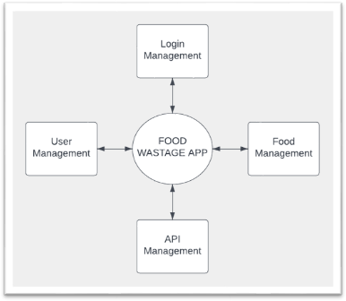

1. **Level 1**: Detailed processes for food donation, recipient request handling, and logistics scheduling.

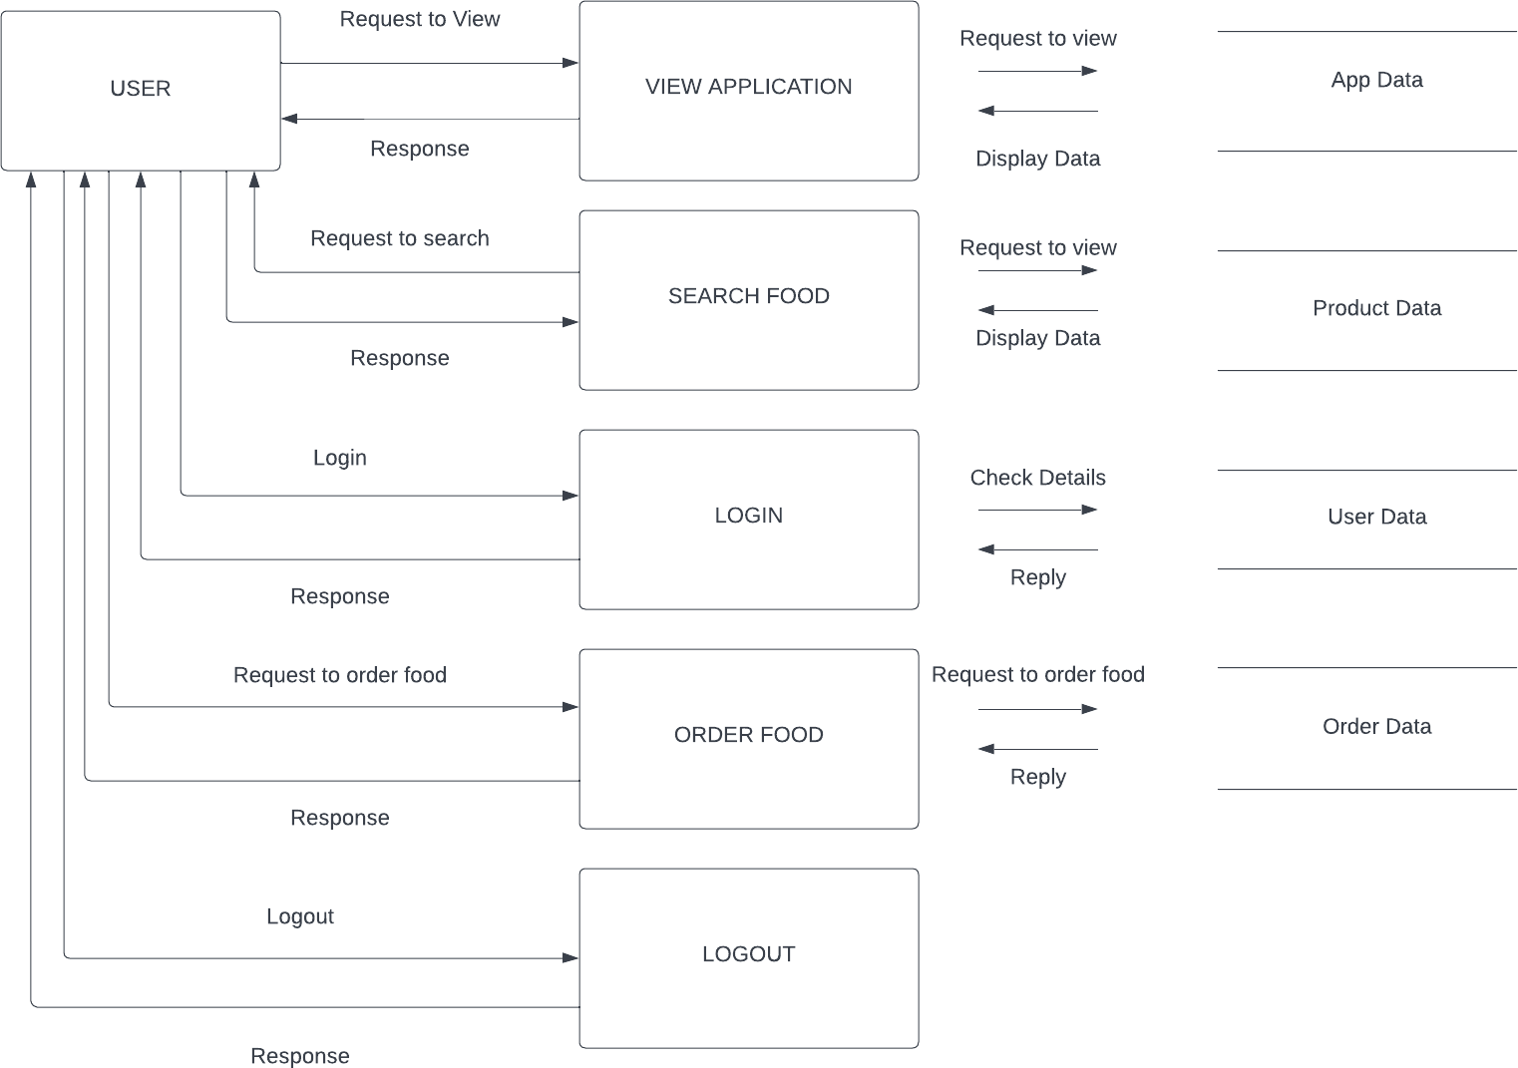

**6.4 Class Diagram**

* **Classes**:
  + User (Donor/Recipient/Admin): Login(), Register()
  + FoodDonation: AddDonation(), ViewDonations()
  + Logistics: SchedulePickup(), TrackDelivery()

**6.5 Sequence Diagram**

1. Donor posts a food donation.
2. Recipient views available donations and requests food.
3. Logistics partner picks up food from donor and delivers it to recipient.

**##7. Implementation Plan**

**7.1 Technology Stack**

1. **Frontend**: React.js
2. **Backend**: Node.js
3. **Database**: MongoDB
4. **Cloud Services**: AWS or Google Cloud for hosting and storage.
5. **APIs**: Google Maps API for geolocation and routing.

**7.2 Development Phases**

1. **Phase 1**: Core functionalities - user registration, food donation, and recipient request management.
2. **Phase 2**: Logistics and notification system integration.
3. **Phase 3**: Advanced features - AI-powered matching and analytics dashboard.

**##8. Risk Analysis**

* **Data Privacy**: Ensure user data protection via encryption and secure storage.
* **Food Spoilage**: Implement strict pickup and delivery timeframes.
* **User Adoption**: Conduct outreach programs to increase user base.

**##9. Conclusion**

The Waste Food Management & Donation project will serve as an effective solution for reducing food waste and addressing hunger issues. By leveraging modern technologies and efficient system modeling, the platform ensures the seamless collection, storage, and redistribution of surplus food.